Project Report on

SERVICE LEVEL AGREEMENT OF
LAN AND WAN



By
SRIKANT BHATTACHARJEE

Under the guidance of

Mr. MRINAL K. PAL
(Head, IT tech & PC)

DEPARTMENT OF INFORMATION TECHNOLOGY SERVICES
TATA STEEL LTD, JAMSHEDPUR

“SERVICE LEVEL AGREEMENT MONITORING SYSTEM”

Developed by

SRIKANT BHATTACHARJEE

A project report submitted in partial fulfillment of the requirement for the degree of
Master of Computer Application

Under
West Bengal University of Technology
Year 2006-2009



Registration Number:

Roll Number:
18810061005

Under the Guidance of
Mr. Mrinal K. Pal
ITS, TATA STEEL

ACKNOWLEDGEMENT

I would like to take this opportunity to thank Mr. Sidharth , Mr. Sandeep Kumar, Ms. Neha, for providing me with an opportunity to undertake this project.

I am especially thankful to my project guide MR. MRINAL KANT PAL, Senior Manager, Network And Communication ITS, TATA STEEL for his encouragement. His guidance helped us in the learning process during the course of the project.

It was a wonderful experience to have the privilege of being a part of the TATA STEEL family and more so the expert and professional guidance provided will certainly go a long way to help strengthen my knowledge in my field.

Srikant Bhattacharjee

Certificate Of Approval

This is to certify that SRIKANT BHATTACHARJEE , student of 3rd year of Master of Computer Application from TECHNO INDIA HOOGHLY has worked under my supervision and guidance from 04th March’2009 to 20th May’2009 and has completed the project for “SERVICE LEVEL AGREEMENT OF LAN AND WAN” successfully.
We appreciate his enthusiasm and commitment during the project tenure and wish him success in his future endeavors.

Project guide
Mr. Mrinal K. Pal
(Head, IT tech & PC)
Information Technology Services,
TATA STEEL, JAMSHEDPUR

1: INTRODUCTION AND OBJECTIVE OF PROJECT:-

Introduction

Before discussing about my project, firstly I am going to tell something about TATA-STEEL, from where I have done my MCA 6th semester project.
Backed by 100 glorious years of experience in steel making, Tata Steel is the world’s 6th largest steel company with an existing annual crude steel production capacity of 30 Million Tones’ Per Annum (MTPA). Established in 1907, it is the first integrated steel plant in Asia and is now the world`s second most geographically diversified steel producer and a Fortune 500 Company.
Tata Steel has a balanced global presence in over 50 developed European and fast growing Asian markets, with manufacturing units in 26 countries.
Tata Steel`s Jamshedpur (India) Works has a crude steel production capacity of 6.8 MTPA which is slated to increase to 10 MTPA by 2010. The Company also has proposed three Greenfield steel projects in the states of Jharkhand, Orissa and Chhattisgarh in India with additional capacity of 23 MTPA and a Greenfield project in Vietnam.
The iron ore mines and collieries in India give the Company a distinct advantage in raw material sourcing. Tata Steel is also striving towards raw materials security through joint ventures in Thailand, Australia, Mozambique, Ivory Coast (West Africa) and Oman. Tata Steel has signed an agreement with Steel Authority of India Limited to establish a 50:50 joint venture company for coal mining in India. Also, Tata Steel has bought 19.9% stake in New Millennium Capital Corporation, Canada for iron ore mining.

Corporate Sustainability
Regarded globally as a benchmark in corporate social responsibility, Tata Steel's commitment to the community remains the bedrock of its hundred years of sustainability. Its mammoth social outreach programmed covers the company-managed city of Jamshedpur and over 800 villages in and around its manufacturing and raw materials operations through uplift initiatives in the areas of income generation, health and medical care, education, sports, and relief.
The Company, fully conscious of its responsibilities to the future generations, has always taken pro-active measures to ensure optimum utilization of natural resources. This is reflected in the ISO-14001 certification that all its operations have achieved for environment management. The SA 8000 certification for work conditions and improvements in the workplace at the steel works in Jamshedpur, along with its Ferro Alloys and Minerals Division, is a reiteration of its commitment towards the Company's employees. Tata Steel has pioneered numerous employee welfare measures such as the 8 hours working day and the three tier joint consultation system of management which have been the platform for nearly 80 years of industrial harmony in its Steel Works in Jamshedpur.

Awards and Recognitions
- Tata Steel India awarded the Deming Application Prize 2008 for excellence in Total Quality Management. It is the first integrated steel company in the world, outside Japan to get this award.
- World Steel Dynamics has ranked Tata Steel as the world's best steel maker (for two consecutive years) in its annual listing in February 2006.
- Tata Steel has been conferred the Prime Minister of India's Trophy for the Best Integrated Steel Plant five times.
- It has been awarded Asia's Most Admired Knowledge Enterprise award five times in 2003, 2004, 2006, 2007 and 2008.
- Conferred the prestigious Global Business Coalition Award for Business Excellence in the Community in recognition of its pioneering work in the field of HIV/ AIDS awareness.
- Tata Steel works has been conferred the prestigious social accountability (SA) 8000 certification by social. Accountability international (SAI), USA. It is the first steel company in the world to receive this certificate.
- Corporate Sustainability Report of Tata Steel hailed by United Nation's Environment Programmed (UNEP) and Standard and poor as strongest, submitted by any corporate house from emerging economies.
- Best governed company Award 2006 for setting high standards in governance practices.
- Tata Steel won "Award for Corporate Social Responsibility in Public health" by US- Indian Business Council (USIBC), Population Services International (PSI) and the center for Strategic and International Studies (CSIS) in 2007.
Now about Information Technology Services, where all software related work have been done.
TATA STEEL’s attempt towards mechanization in computing dates back to over 50 years ago, with the usage of Hollerith machine. In 1967,a Computer Services division was formed, which made a start by computerizing payroll, accounting and materials management function. Since then this division, now known as Information Technology services (ITS), has been responsible for the computerization efforts at Jamshedpur and its other profit centers, and in the marketing division at 27 locations.

Information Technology services (ITS)
Information Technology services (ITS) is as in house It services provider to all departments of Tata Steel. The department is entrusted with the responsibility of assessing customer requirements, architecting IT solution, and delivering IT services to Tata Steel. ITS is also responsible for supporting the information management process which is one of the Tata Steel’s kit business processes. ITS has committed itself of creating business value for its customers and aspires to take Tata Steel to new levels of excellence through e-transformation .The reach and range of information technology have been significantly expended, with best communication practices.
The Information Technology Services Department has been divided into several groups such as Network and Communication, Technical Support Group(TSG), Oracle Development HR- system Group, Center(ODC),HRIS group and so on…..
We have work with Network And Communication (System)

SLA
A service-level agreement (SLA) is a negotiated agreement between two parties where one is the customer and the other is the service provider. This can be a legally binding formal or informal 'contract' (see internal department relationships). Contracts between the service provider and other third parties are often (incorrectly) called SLAs — as the level of service has been set by the (principal) customer there can be no 'agreement' between third parties (these agreements are simply a 'contract').
The SLA records a common understanding about services, priorities, responsibilities, guarantees and warranties. Each area of service scope should have the 'level of service' defined. The SLA may specify the levels of availability, serviceability, performance, operation, or other attributes of the service.

Automated Web-based SLA Report Generation
SLA report generation is an automated function -immediately upon completing the SLA template an initial compliance calculation is performed and then a web report is auto-generated showing current compliance results.
Historical SLA Compliance Reporting
SLA reports also provide historical perspectives – selecting the ‘Report’ tab in the web report will display SLA compliance results for past periods in tabular format. The history report will reveal improved or degrading compliance trends, additionally past periods listed in the history report can be drilled into for analysis. An additional key feature of SLA historical reporting is the ability to modify and recalculate past SLA periods (i.e. add forgotten exclude period).
Types of periods:
- Fulfilled period
- Breached period(downtime period)
- Planned breached period

Template driven SLA definition:
Graphical SLA templates included SLA definition – SLA configuration options include, and are not limited to; Compliance period (for example, 1 day, 1 week, 1 month, 1 year), Operating period (for example, “8:30am to 6:30pm”, “Mon-Suni”,”24x7 hours”), Compliance threshold (for example, 99.5%), and more. Web-based SLA compliance reports are automatically generated upon completion of the SLA definition.

Table of Content

Sl no. | Description
1  2  3  4  5  6  7  8  9  10 | Requirement analysis  System Architecture  Software Usage  DFD  ERD  Web layout  Table structure  Testing  Bibliography  Conclusion

Requirement Analysis
The solution provides a graphical interface for defining SLA parameters, i.e. compliance period, breached period, fulfilled period, planned downtime and much more. Improve the availability of your IT services by getting fast, accurate updates about all your critical system services and then proactively taking the necessary steps to avoid unnecessary service outages. This report lists the percentage of time each service has been in OK, Warning, Critical, Maintenance, or Unknown states over any period of time you specify. Produce in-depth tabular reports for all your servers that will give you exact growth statistics for all file systems on all servers that you wish to analyze and show you just how fast they are growing over specific time periods.
Required modules are
- Date based SLA monitoring.
- Store data into sql server database from server database which in CSV format.
- Calculate uptime & downtime.
- Calculate uptime percentage and downtime percentage.
- Edit the undesirable downtime and also store the cause of edit.
- Store all the calculated value in the table.
- Should have option for add server and location under the respective server.

Primary features:
- Automated web-based SLA report generation
- SLA compliance historical reporting with trend analysis
- Comprehensive IT infrastructure data analysis.
- New Servers can be added very easily
- Monthly Average uptime & downtime can calculate

Key benefits:

- Reduces IT labor/costs associated with data analysis to determine SLA compliance
- Provides compliance history to support IT in SLA compliance review meetings
- Dramatically reduces the bottom-line impact of SLA violation penalties

SYSTEM ARCHITECTURE

SLA COMPLIANCE REPORTS
HISTORICAL SLA COMPLIANCE REPORTING
REPORT
ENGINE GENERATION

WRITTEN
SERVICE LEVEL AGREEMENT
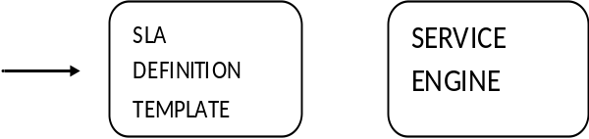

DATABASE

Tools and Environment

Operating System :
Window XP and Window server 2003;

Software:

Front-End :- ASP.NET Using Visual Basic
Back-End :- Microsoft SQL Server 2005, Microsoft Access 2003

Visual Studio 2005
Visual Studio is a complete set of development tools for building ASP.NET Web applications, XML Web Services, desktop applications, and mobile applications. Visual Basic, Visual C++, Visual C#, and Visual J# all use the same integrated development environment (IDE), which allows them to share tools and facilitates in the creation of mixed-language solutions. In addition, these languages leverage the functionality of the .NET Framework, which provides access to key technologies that simplify the development of ASP Web applications and XML Web Services

The .NET Framework
The .NET Framework is a multi-language environment for building, deploying, and running XML Web Services and applications. It consists of three main parts:
- Common Language Runtime Despite its name, the runtime actually has a role in both a component's runtime and development time experiences. While the component is running, the runtime is responsible for managing memory allocation, starting up and stopping threads and processes, and enforcing security policy, as well as satisfying any dependencies that the component might have on other components. At development time, the runtime's role changes slightly; because it automates so much (for example, memory management), the runtime makes the developer's experience very simple, especially when compared to COM as it is today. In particular, features such as reflection dramatically reduce the amount of code a developer must write in order to turn business logic into a reusable component.
- Unified programming classes The framework provides developers with a unified, object-oriented, hierarchical, and extensible set of class libraries (APIs). Currently, C++ developers use the Microsoft Foundation Classes and Java developers use the Windows Foundation Classes. The framework unifies these disparate models and gives Visual Basic and JScript programmers access to class libraries as well. By creating a common set of APIs across all programming languages, the common language runtime enables cross-language inheritance, error handling, and debugging. All programming languages, from JScript to C++, have similar access to the framework and developers are free to choose the language that they want to use.

SQL SERVER
Microsoft SQL Server 2005 is a database and data analysis platform for large-scale online transaction processing (OLTP), data warehousing, and e-commerce applications.
Microsoft SQL Server 2005 includes a variety of highly precise, configurable security features. These features can empower administrators to implement defense-in-depth that is optimized for the specific security risks of their environment. The following table lists important security-related topics
Microsoft SQL Server 2005 includes a complete set of graphical tools and command prompt utilities that allow users, programmers, and administrators to:
- Administer and configure SQL Server.
- Determine the catalog information in a copy of SQL Server.
- Design and test queries for retrieving data.
- Copy, import, export, and transform data.
- Provide diagnostic information.
- Start and stop SQL Server.
In addition to these utilities, SQL Server contains several wizards to walk administrators and programmers through the steps needed to perform more complex administrative tasks.
This section of Books Online provides general information about the tools and utilities as well as topics that you can access directly from through Help or by pressing F1
- have similar access to the framework and developers are free to choose the language that they want to use.

SOFTWARE ENGINEERING APPROACH

WATER FALL MODEL
The waterfall model is a sequential software development process, in which progress is seen as flowing steadily downwards (like a waterfall) through the phases of Conception, Initiation, Analysis, Design (validation), Construction, Testing and maintenance.

Project Model

System feasibilty
Requirement analysis & project planing
System design
coding
Testing
Installation
Operation & maintenance
Feasibilty Report
Requirement Analysis
System Design
programs
Test plan ,test report
Installation Report
Waterfall model

Feasibility Study: - Feasibility is the determination of whether or not a project is worth doing. The process followed in making this determination is called feasibility study. This type of study determines if a project can and should be taken. Once it has been determined that a project is feasible, the analyst can go ahead and prepare the project specification which finalizes.

Project requirements. Generally, feasibility studies are under taken with tight time constraints and normally culminate in a written and oral feasibility report. The contents and recommendations of such a study will be used as a sound basis for deciding whether to proceed, postpone or cancel the project. Thus, since the feasibility study may lead to the commitment of large resource, it becomes necessary that it should be conducted competently and that no fundamental errors of judgment are made.

- Technical feasibility: -
This is concerned with specifying equipment and software that will successfully satisfy the user requirement. In my case, the project is technically feasible, because the TATA STEEL has got all the software support, hardware support, good working location, good working condition and all other supporting equipment. As far as specification of equipment (in details) is concerned, I have given this under the heading “software and hardware requirement specification”. In addition to this, this project was technically feasible because of the following reason :-

- This project will give the facility to produce outputs in a given time.

- Response time under certain conditions is very fast.

- Ability to process a certain volume of transaction at a particular speed.

- Facility to communicate data to distant location.

- Compatible with hardware available in TATA STEEL LTD.

- The software can run on different platforms as well. Means, other department of TATA STEEL can also use the same software. In other words, Software is portable because Form runtime sql server runs in Internet Explorer.

- Economical Feasibility: -

This project is economically feasible as well. As we know economic analysis is the most frequently used technique for evaluating the effectiveness of a proposed system. More commonly known as cost/benefit analysis, the procedure is to determine the benefits and saving that are expected from a proposed system and compare them with cost. If benefits outweigh costs, a decision is taken to design and implement the system. Otherwise, further justification or alternative in the proposed system will have to be made if it is to have a chance of being approved. This is ongoing effort that improves in accuracy at each phase of the system life cycle.

In my case the system was economically feasible in the following way:-
- No extra money to be invested in hardware, Software and other equipments to support this new system. Existing equipment and other supports in TATA STEEL are sufficient.

If the same software package bought from the open market, it could have incurred more money.

- Operational Feasibility:-

Proposed project are beneficial only if they can be turned into information system that will meet organization operating requirements. Basically this tesy of feasibility asks if the system will work when it is developed and installed. It mainly related to organizational and political aspects. The point to be considered is,

- What change will be bought with the system?

- What organizational structures are distributed?

Our proposed system satisfies the entire feasibility test required to make the system worth making.

MONITORING AND CONTROLLING

- Monthly Project review meeting with the project head

- The projet head will do frequently tracking & updating in the project schedule

- Fortnight project status report will be sent by the project leader to the concern person in order to inform the progress of the project.

Effort Estimation
Project Start date (as provided by project manager) : 4th march 2009

Project deadline(as provided by project manager ): 21 may 2009

Activity | Personal | Days | Start date | Finish date
Requirement analysis | 1 | 7 | 4th march 2009 | 11th march 2009
SRS | 1 | 7 | 12th march 2009 | 19th march 2009
SDD & coding | 2 | 45 | 20th march 2009 | 5th may 2009
Testing & documentation | 2 | 15 | 6th may 2009 | 21 may 2009

SYSTEM REQUIREMENT SPECIFICATION

Project Name:SLA Monitoring

Version:1.0

Date:4th March,2009

Prepared By:Srikant Bhattacharjee

Table of Contents

- Project Overview

- Major Work Activity

- Data Flow Diagram

- Entity Relationship Diagram

Project overview

The project “ SERVICE LEVEL AGREEMENT MONITORING ” is entirely a computer oriented networking software which can monitor network services .

It calculates uptime & downtime. It stores the whole data into sql server database for future usage.

MAJOR WORK ACTIVITY

Pages | WorkDone
New user entry | This module is mainly used for new user. After getting approvition, new user can monitor the pages which are not restricted.
New administrator entry | This module is mainly used for new user. After getting approvition, new administrator can monitor the whole module.
Add server name | This module helps to store a new server & location under that server .
Single day monitoring | This module helps to monitor single day  Status & calculate uptime% and downtime%.
Multiple day monitoring | This module helps to monitor multiple days means a range of dates status & also calculate uptime% and downtime%.
Edit status | This module helps to edit the status as per requirements. It is only accessed by ADMINISTRATOR.
Back up(store) | This module helps to take backup in sql server database. Its require some time to store all files of the respective date.
Back up(delete) | This module helps to delete the tables from sql server database. It delete all files of the respective date.
Status (single) | It shows the conditional status of that day & also shows the uptime % & downtime %.
Status(multiple) | It shows the conditional status of that days & also shows the uptime % & downtime %
Historical query | It shows the average uptime% & average downtime % of a month of a particular site.

DATAFLOW DIAGRAM (DFD)

SLA
MONITORING
SYSTEM

ADMINISTRATOR
HISTORICAL SLA COMPLIANCE REPORTS

USERS DETAILS;
ADMIN DETAILS;
SERVER DETAILS;
HISTORICAL SLA COMPLIANCE REPORTS

SLA
DEFINITION
TEMPLATE

USERS

Physical DFD

SLA Compliance report
SLA DEFINITION TEMPLATE
(AUTHORIZED)
Add User Request
SLA DATABASE
User_dtls

ADMIN / USER

3
Add new user / Admin

2
ADDING NEW SERVERS.

1
SLA
COMPLIANCE
REPORT
GENERATOR.

SERVER DATABASE
SERVER DETAILS

Add User Response

LOGICAL DFD

ADD USER
REQUEST
ADD SERVER REQUEST

GENERATE / EDIT
SLA Compliance Report
SLA DATABASE
User
Admin
1
SLA
COMPLIANCE
REPORT
GENERATOR.

3
Add new user / Admin
2
ADDING NEW SERVERS.

USER DATABASE
SERVER DATABASE
SLA Compliance Report

RETRIVE DATA

ADD / MODIFY

Entity Relationship Diagram

Admin
User_dtls
User_Id
Ans
Password
Name
Email
Works_for
ques
Admin
Auth. User
Creates
Tempory Tables
Calculates
Add Server & Location
SLA
Server_nms
LOC
Server
< Server names >
Up_time
Location
Down_time
Up_time_perc
Date
Down_time_perc
Value
Comments
Status
Time
Message
Contact_no
P_no

SYSTEM DESIGN DOCUMENT

Project Name:SLA Monitoring

Version:1.0

Date:11th March,2009

Prepared By:Srikant Bhattacharjee

WEB-DESIGN:-

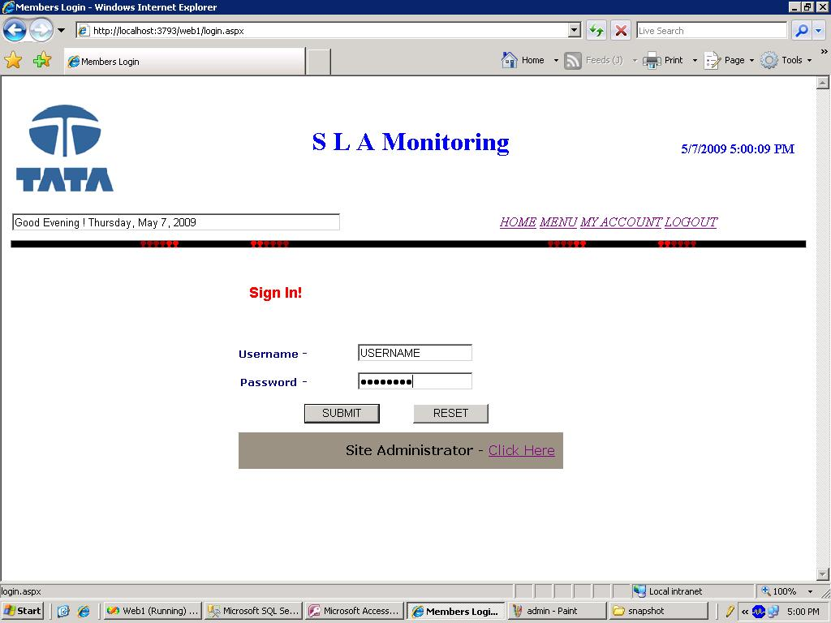

USER LOGIN PAGE

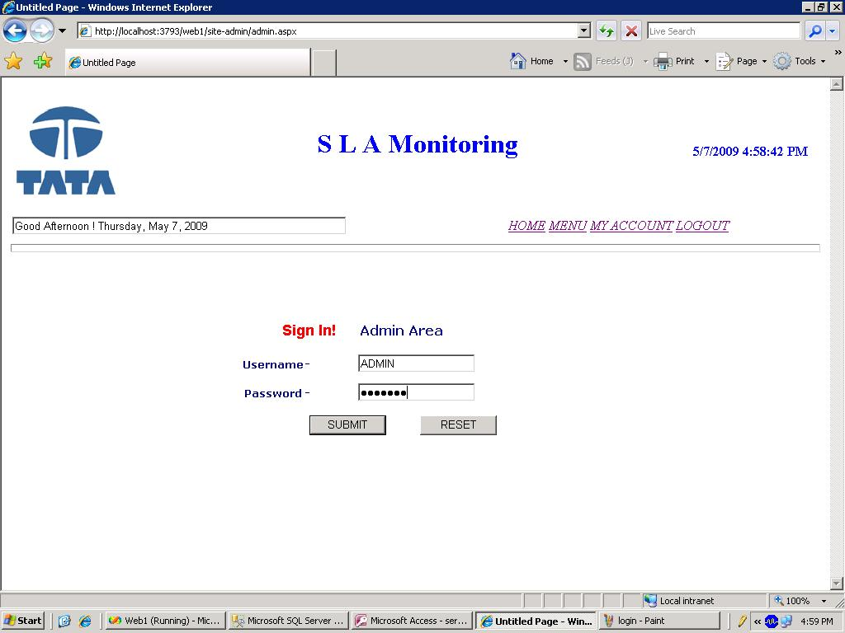
ADMIN LOGIN PAGE

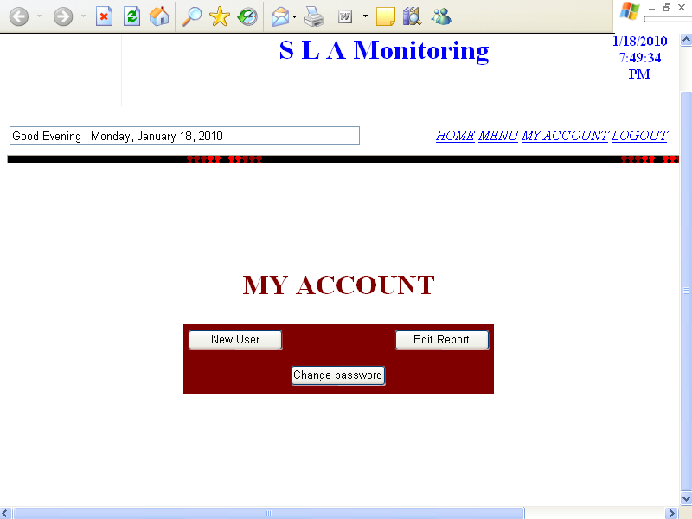

MY ACCOUNT PAGE

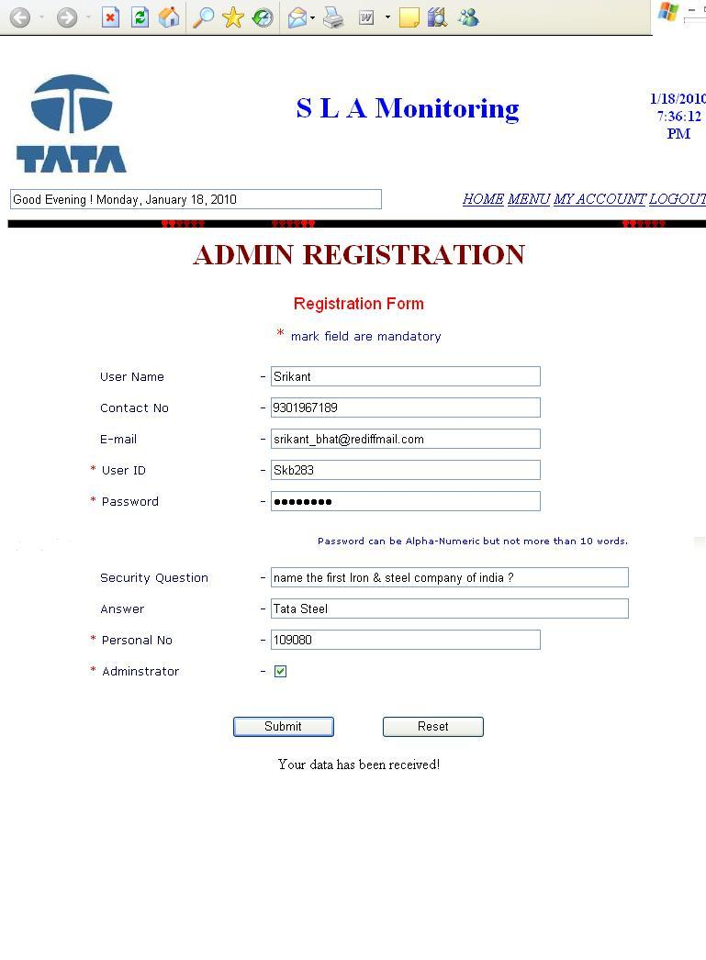
ADMIN / USER REGISTRATION FORM

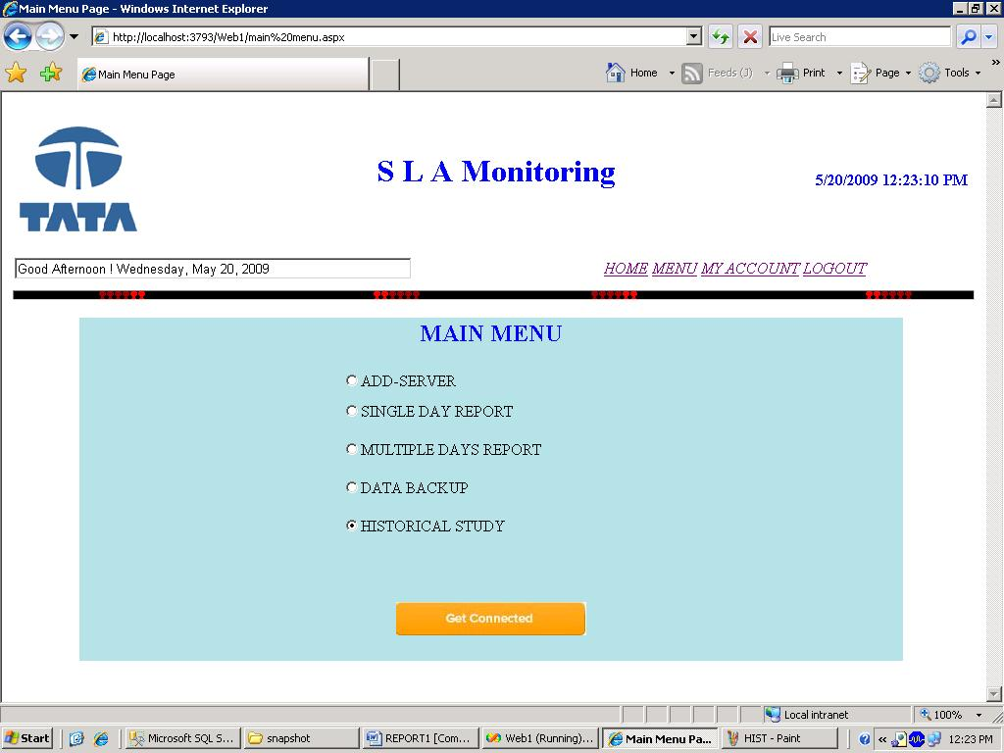

MAIN MENU PAGE

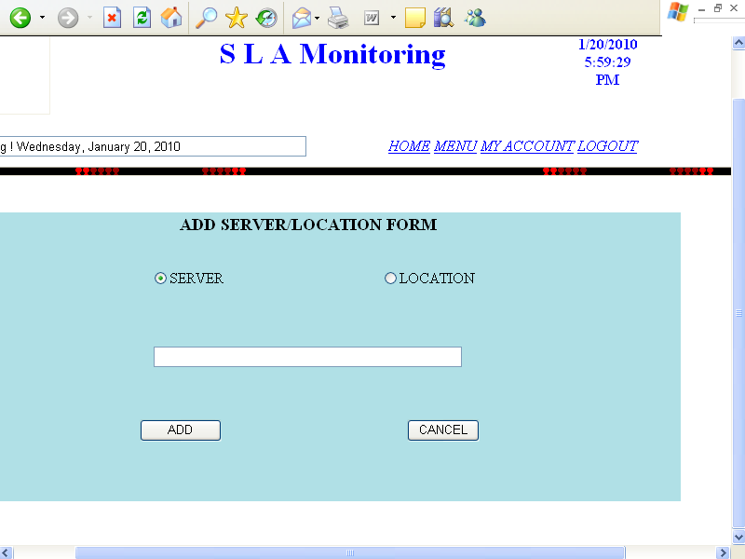

ADD SERVER PAGE

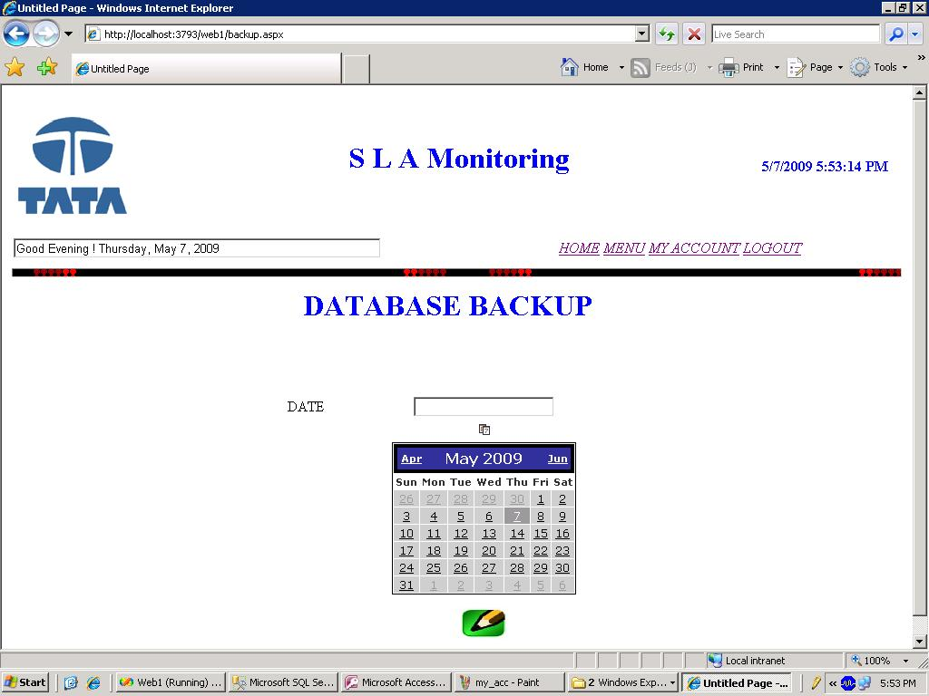

DATABASE BACKUP PAGE

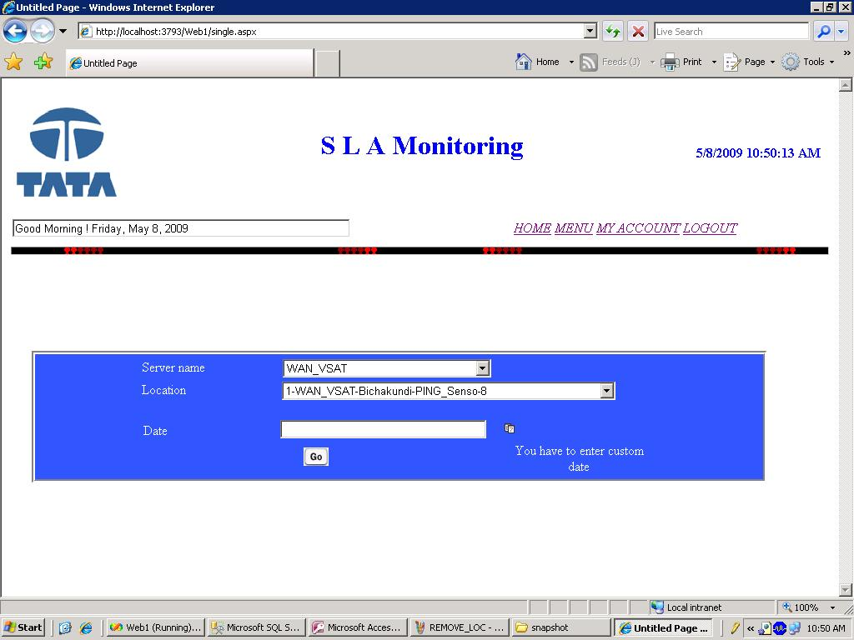

SINGLE DAY REPORT QUERY PAGE (with warning message)

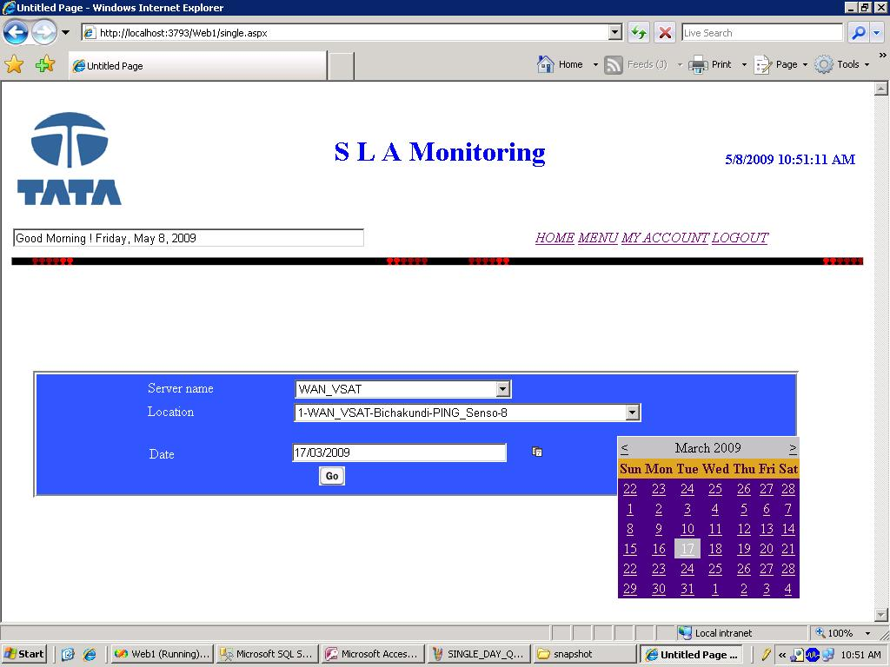

SINGLE DAY REPORT QUERY PAGE

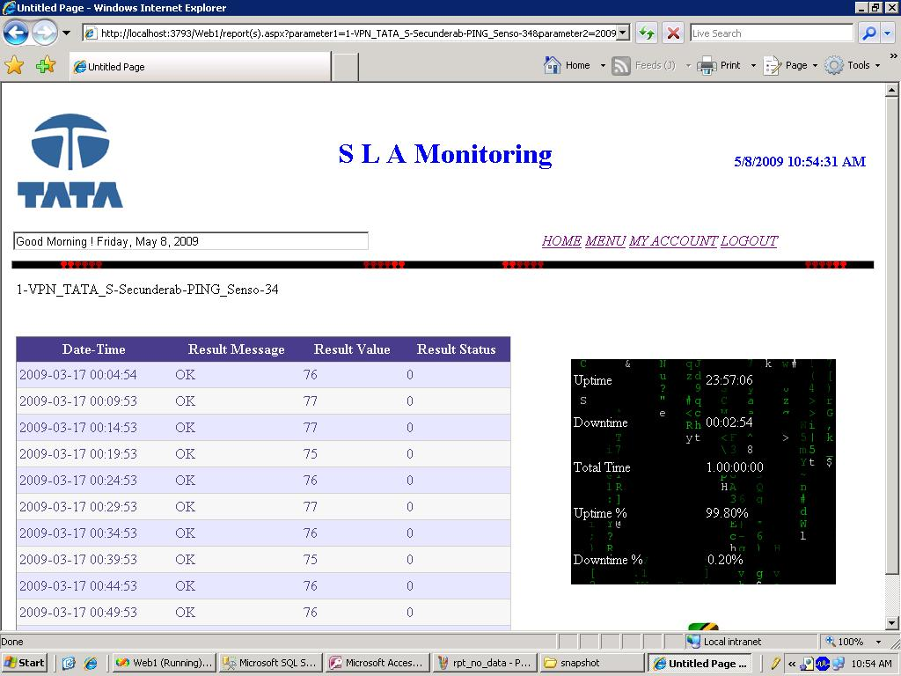

SINGLE DAY REPORT PAGE

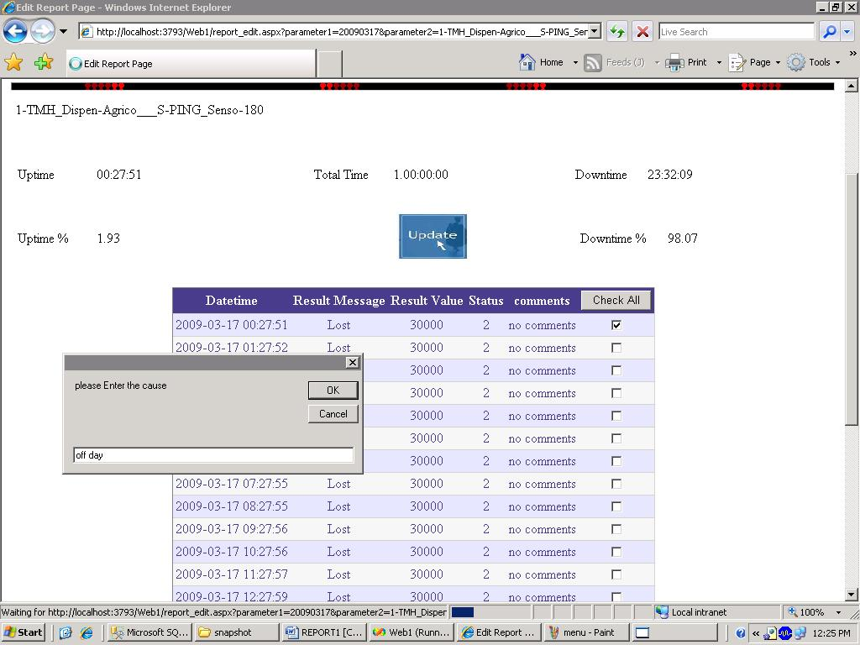

SINGLE DAY REPORT EDIT PAGE

SINGLE DAY REPORT EDIT PAGE

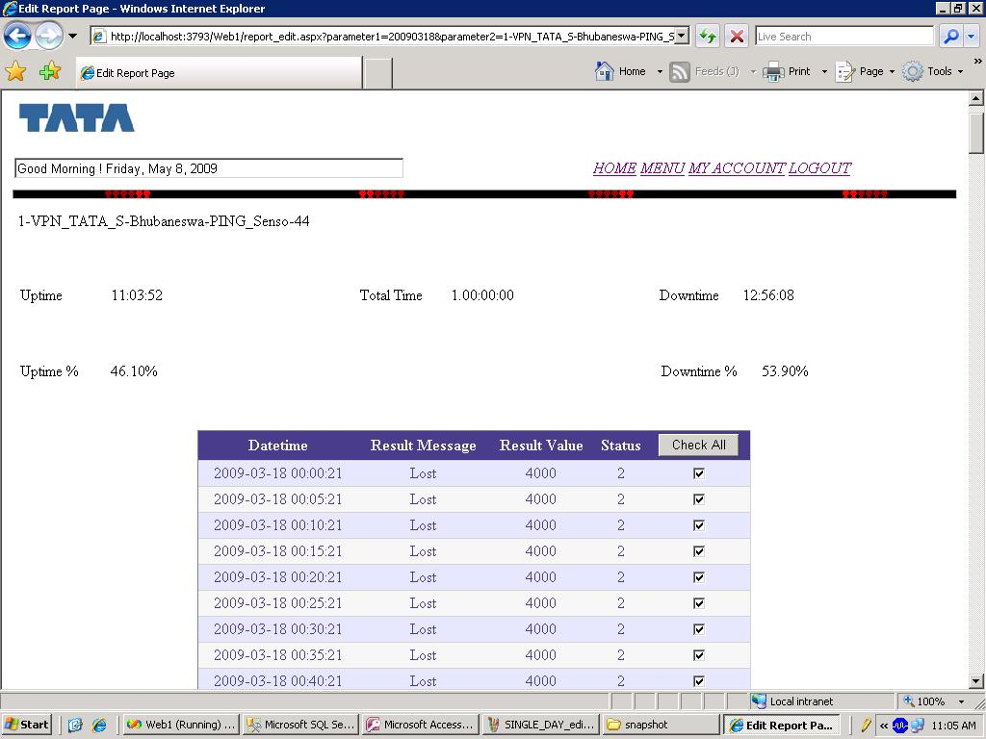

SINGLE DAY REPORT EDIT ALL PAGE

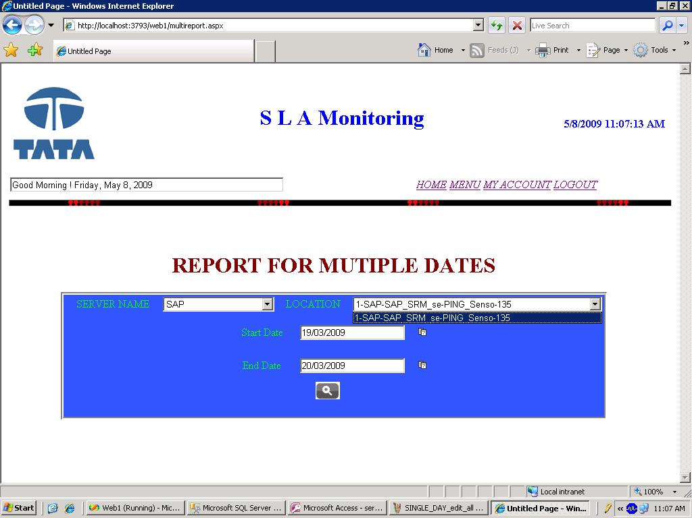

MULTIPLE DATE REPORT PAGE

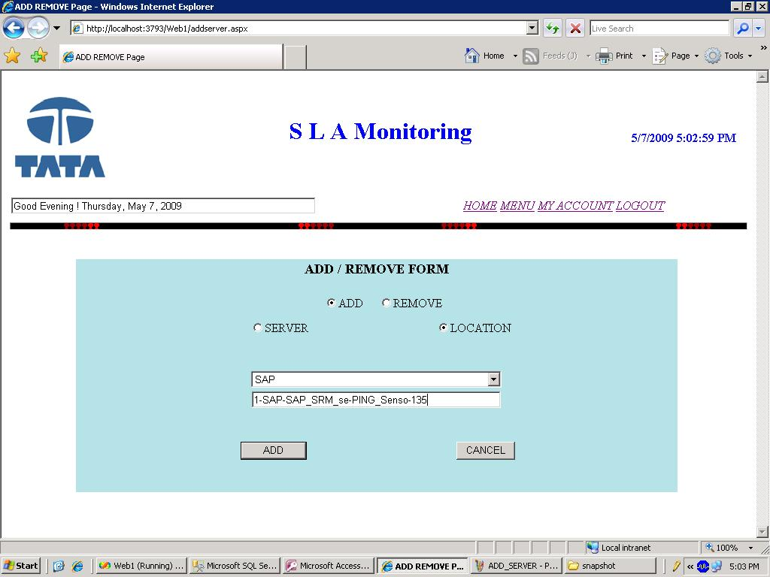

ADD LOCATION PAGE

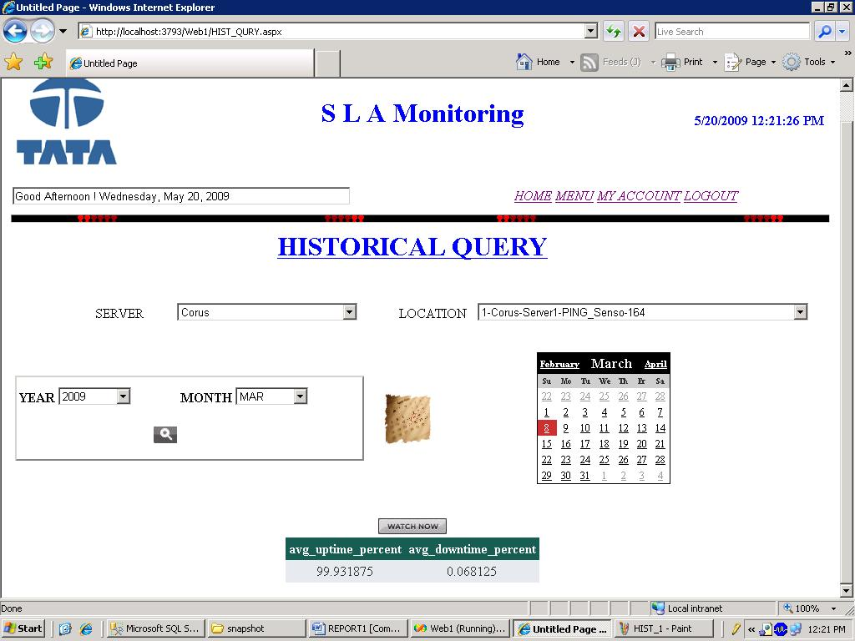

AVG UP/DOWN TIME PERCENTAGE FOR MONTH

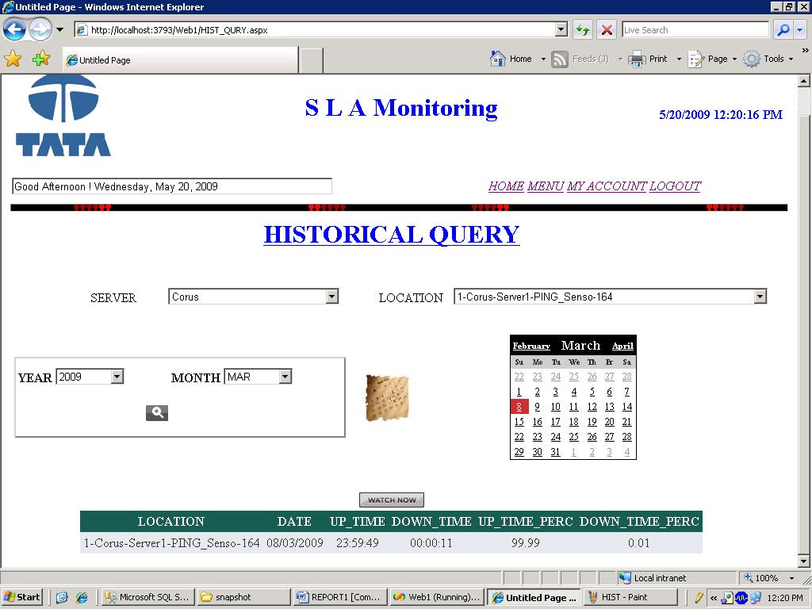

AVG UP/DOWN TIME PERCENTAGE

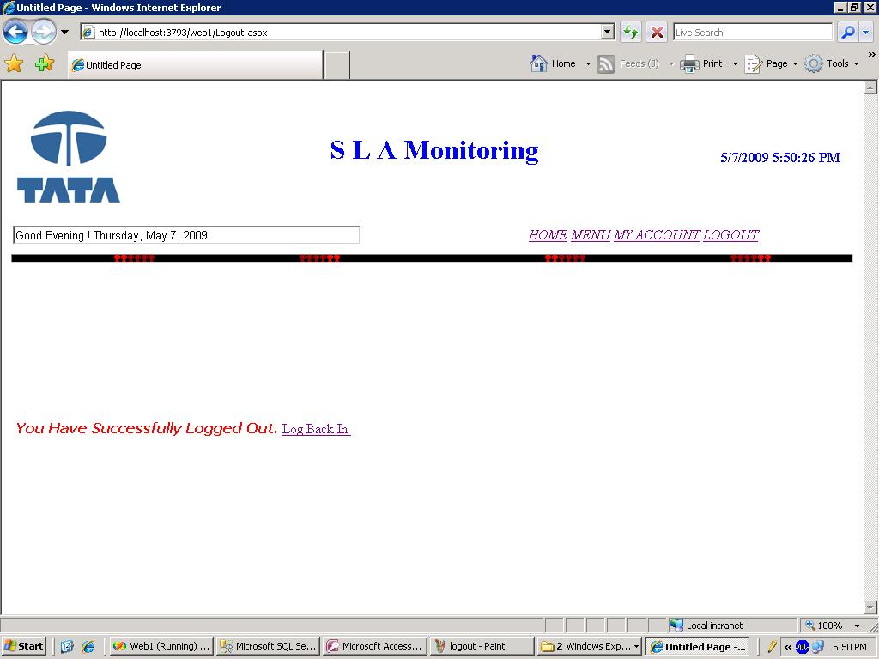

LOGGED OUT PAGE

CODING ANALYSIS

Project Name : SLA Monitoring

Version : 1.0

Date : 20th May,2009

Prepared By : Srikant Bhattacharjee

Table structure

We have used 5 tables for this application. So many tables are created at the run time and also dropped at the run time if required. There are 3 tables are created in sql server 2005 and 2 tables are created MS Access.

Using MS Access

User_dtls

Field name datatype

Email Text
Name Text
Ans Text
Ques Text
P_no number
Contact_no number
User_id Text
Password Text

Using Sql Server :

Server_nms

Field name datatype

Server varchar(50)

Loc : Loc table is also dynamically change after adding location under a server

Field name datatype

<Location names> varchar(200)

Sla

Field name datatype

Location varchar(100)
Date varchar(20)
Up_time varchar(20)
Down_time varchar(20)
Up_time _perc Float
Down_time_perc Float

<dynamically created tables>

Field name datatype

Time varchar(20)
Value int
Message varchar(50)
Status int
Comments varchar(200)

Examples of table

Table name : server_nms

Server

WAN_VSAT
VPN_TATA_STEEL
SAP
CORUS
ITS_SERVER
VPN_TUBE
VPN_WIRE_DIVISION
TMH
& many more

Table name : loc

WAN_VSAT | VPN_TATA_STEEL | SAP | CORUS | ITS_SERVER | TMH | ….
Noamundi-1 | Delhi-so-165 | Sap-server-109 | Corus server-164 | Its-server-148 | Kadma dispensary-112
Jamshedpur-110 | Delhi stk-187 |  | Corus server-166 |  | Bistopur- dispensary-116
Chandigarh-35 | Bangalore-41 |  |  |  | Tmh-111
28 locations more | 43 locations more |  |  |  | 4 locations more

Dynamically created tables

Table names : 20090315-164

Time | Result value | Result message | Status | Comments
15/03/2009 00:02:01 | 230 | Ok | 0 | No comments
15/03/2009 00:07:01 | 20 | Ok | 0 | No comments
15/03/2009 00:012:01 | 4000 | lost | 2 | No comments
15/03/2009 00:17:05 | 4000 | lost | 2 | No comments
15/03/2009 00:22:05 | 30000 | lost | 0 | Site off
15/03/2009 00:27:05 | 30000 | lost | 0 | Site off
15/03/2009 00:32:05 | 30000 | lost | 0 | Site off
15/03/2009 00:37:04 | 30000 | lost | 0 | Site off

Table name : sla

Location | Date | Uptime | Downtime | Uptime_perc | Downtime_perc
Noamundi-1 | 15/03/2009 | 1 00:00:00 | 00:00:00 | 100 | 0
Bangalore-41 | 19/03/2009 | 22:00:00 | 2:00:00 | 91.66 | 8.34

TESTING ANALYSIS

Project Name : SLA Monitoring

Version : 1.0

Date : 5th May,2009

Prepared By : Srikant Bhattacharjee

TEST PLAN

Test means the process of analyzing a software item to detect the difference between exiting and required conditions and to evaluate the features of the software item. Once the test plan is ready and the best cases are completely designed, a different level of testing starts.

1> Unit Testing :

The unit test is performed to test the validity of individual units. This is done I in the coding phase interactive coding. This constitutes majority of functionality test of each logical unit.

2> Integration testing :

When all the development of all units or modules are computed and integrated, the integration phase is started. In this phase the interface between the modules is tested. This test basically verifies whether inter module exchange of information and events are as per required system behaviors.

3>System Testing :

System testing phase incorporates the performance stress testing so as to meet the product criteria with respect to the required benchmarks. This is a necessary test for highly data intensive product.

Software testing topics

Defects and failures
Not all software defects are caused by coding errors. One common source of expensive defects is caused by requirements gaps, e.g., unrecognized requirements, that result in errors of omission by the program designer. A common source of requirements gaps is non-functional requirements such as testability, scalability, maintainability, usability, performance, and security.
Software faults occur through the following processes. A programmer makes an error (mistake), which results in a defect (fault, bug) in the software source code. If this defect is executed, in certain situations the system will produce wrong results, causing a failure.

Compatibility

A frequent cause of software failure is compatibility with another application, a new operating system, or, increasingly, web browser version. In the case of lack of backward compatibility, this can occur (for example...) because the programmers have only considered coding their programs for, or testing the software upon, "the latest version of" this-or-that operating system. The unintended consequence of this fact is that: their latest work might not be fully compatible with earlier mixtures of software/hardware, or it might not be fully compatible with another important operating system. In any case, these differences, whatever they might be, may have resulted in (unintended...) software failures, as witnessed by some significant population of computer users.

Input combinations and preconditions
A very fundamental problem with software testing is that testing under all combinations of inputs and preconditions (initial state) is not feasible, even with a simple product. This means that the number of defects in a software product can be very large and defects that occur infrequently are difficult to find in testing. More significantly, non-functional dimensions of quality (how it is supposed to be versus what it is supposed to do) -- for example, usability, scalability, performance, compatibility, reliability—can be highly subjective; something that constitutes sufficient value to one person may be intolerable to another.

Testing methods

Software testing methods are traditionally divided into black box testing and white box testing. These two approaches are used to describe the point of view that a test engineer takes when designing test cases.

Black box testing
Black box testing treats the software as a "black box," without any knowledge of internal implementation. Black box testing methods include: equivalence partitioning, boundary value analysis, all-pairs testing, fuzz testing, model-based testing, traceability matrix, exploratory testing and specification-based testing.
Specification-based testing
Specification-based testing aims to test the functionality of software according to the applicable requirements.Thus, the tester inputs data into, and only sees the output from, the test object. This level of testing usually requires thorough test cases to be provided to the tester, who then can simply verify that for a given input, the output value (or behavior), either "is" or "is not" the same as the expected value specified in the test case.

White box testing

White box testing, by contrast to black box testing, is when the tester has access to the internal data structures and algorithms (and the code that implement these)
Types of white box testing
The following types of white box testing exist:
API testing (application programming interface) - Testing of the application using Public and Private APIs.
code coverage - creating tests to satisfy some criteria of code coverage. For example, the test designer can create tests to cause all statements in the program to be executed at least once.
fault injection methods.
mutation testing methods.
static testing - White box testing includes all static testing.

Test plan

A test specification is called a test plan. The developers are well aware what test plans will be executed and this information is made available to the developers. This makes the developers more cautious when developing their code. This ensures that the developers code is not passed through any surprise test case or test plans.

Test log

Test item | Data item | System input | Execute output | Validation
Single status | Location name | Select Server name from dropdown list | Location names in the dropdown list | Location ddl shows blank if 1st cell of the database is blanked.
Report-single | Gridview | Select data on the basis of date | No gridview was shown | No data ,so no gridview
Edit | Input comments | given by user | Imput box has not come on the center of screen | Must have to modify
Add location | Textbox | Given by user | Stored into loc table | Must select the server first (by default selected server)

BIBLOGRAPHY:-

“MSDN Library” ,Microsoft Visual studio 2005

DBMS Concept – Korth

www.w3schools.com

www.aspnet100.com

www.daniweb.com

www.expertexchange.com

Black Book –ASP.net

ASP.net using C# & vb- wrox publication

Introduction to System Analysis and Design

Project documentation published by IBM(Tata steel Outsource)

CONCLUSION

When we had embark upon this project, we had quite a few things in our mind.
But it was obsessive desire on our part to make things work out that we were able to almost achieve all of what set out to accomplish. The work we have done widen the scope of doing, get some more innovative idea as well as effective work in these field.

Our work has laid the foundation of taking up challenging work in various fields that Require huge computing.

Our proposed system has automated the manual work done till date and works effectively and efficiently.

